- Create a new file named `notes.txt` using the vi editor.

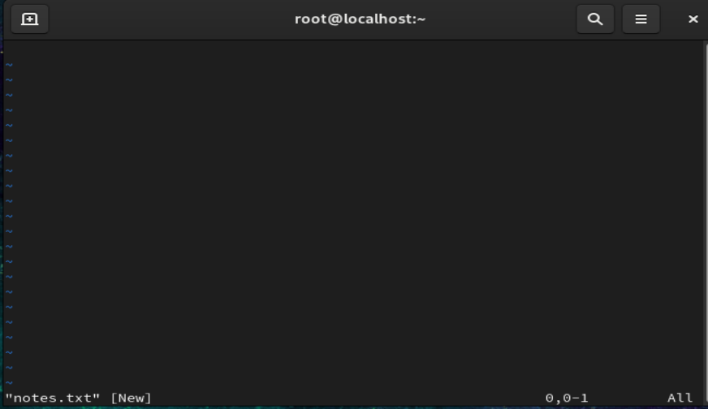
- Open `notes.txt` in vi and write at least five lines of text.
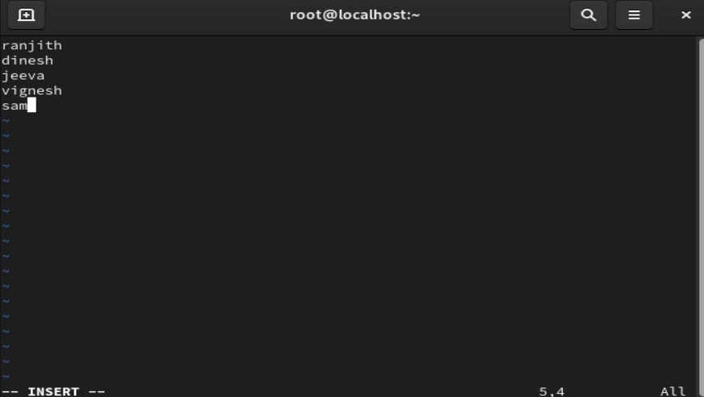

- Save the file and exit the vi editor.
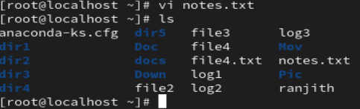
- Reopen `notes.txt` using vi.

- Edit one existing line in the file.
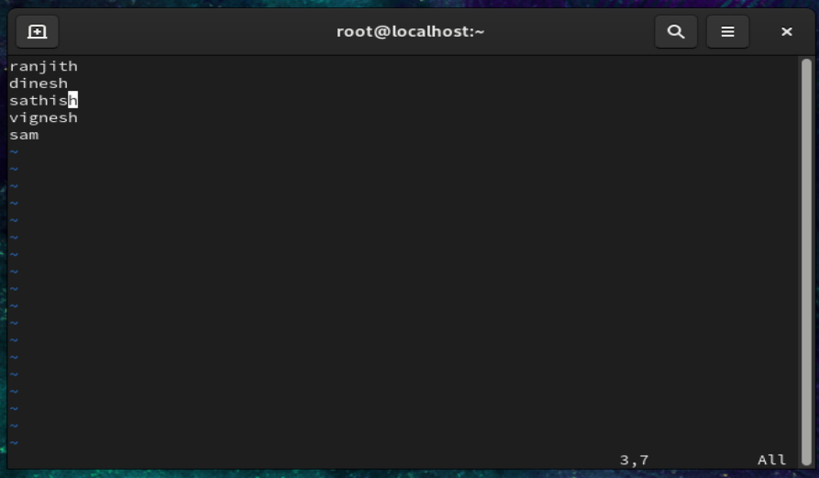
- Save the changes and exit.
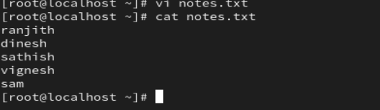

- Display the complete contents of `notes.txt` using the cat command.
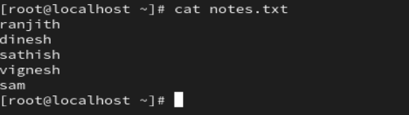
- Display the contents of `notes.txt` with line numbers.
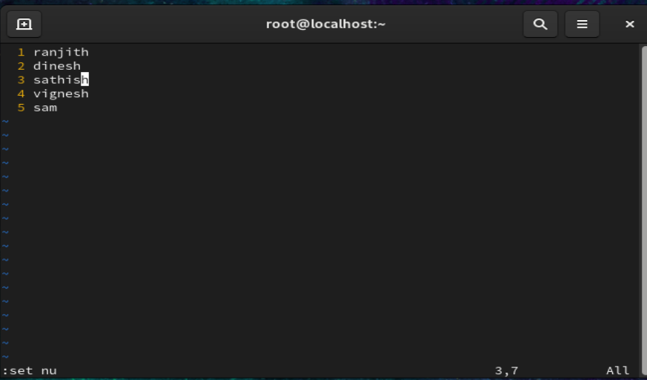
- Create another file named `data.txt` with multiple lines of text.
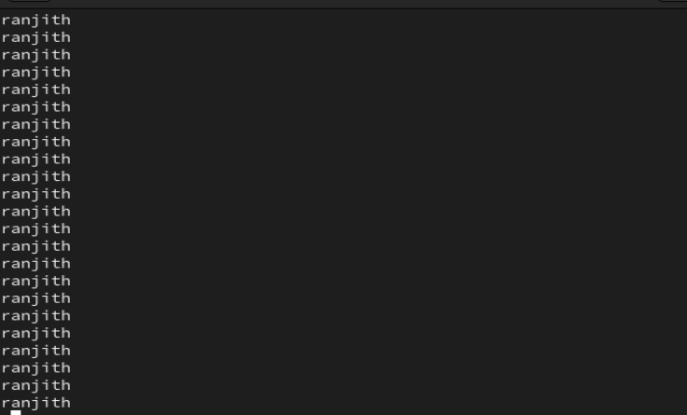
- Display both `notes.txt` and `data.txt` together using a single command.
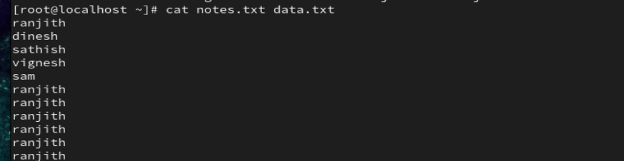

- View the contents of `notes.txt` using the more command.
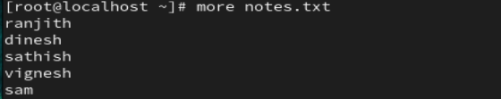
- Scroll through `notes.txt` using the less command.
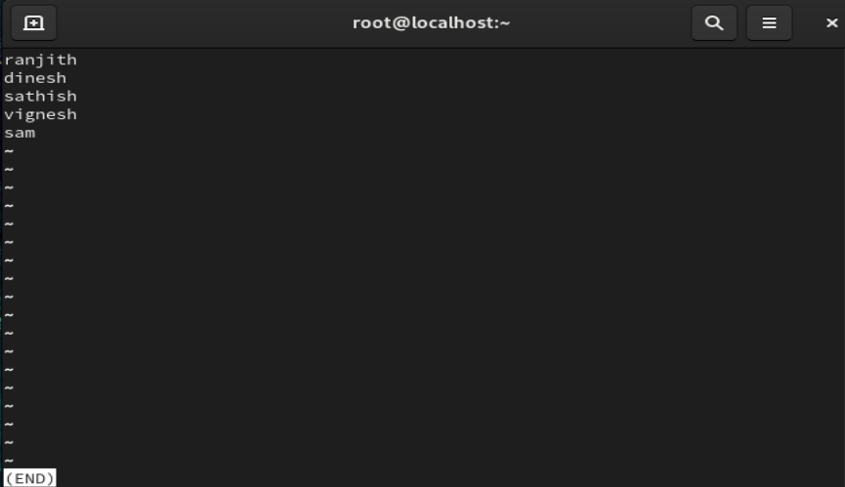
- Exit from the less command after viewing the file.
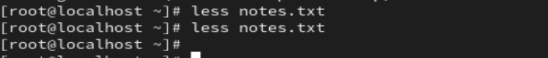

- Display the first 5 lines of `notes.txt`.
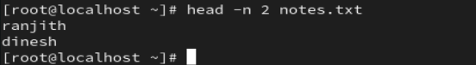
- Display the first 10 lines of `notes.txt`.
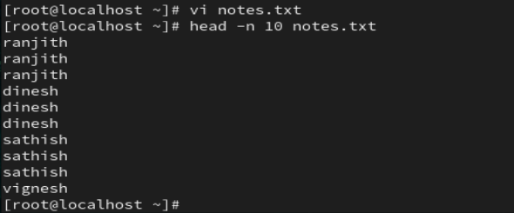

- Display the last 5 lines of `notes.txt`.
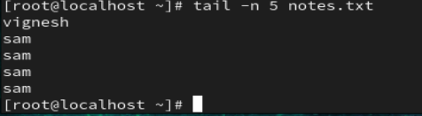
- Display the last 10 lines of `notes.txt`.
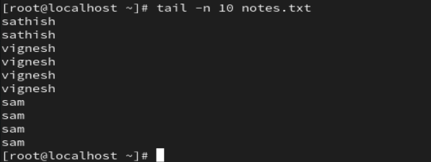

- Add more lines of text to `notes.txt` using the vi editor.
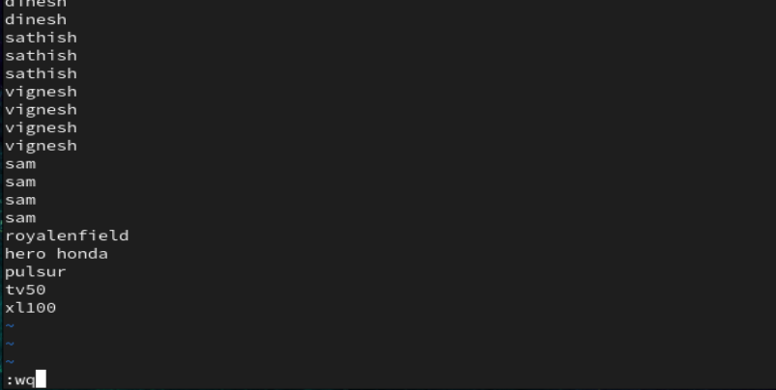
- View only the last few lines of `notes.txt` after the update.
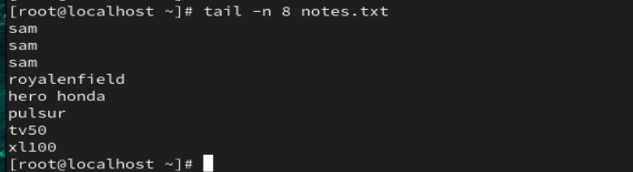
- Observe the difference between head and tail commands.
Head – showing the first 10 lines 
Tail -showing last 10 lines or some lines


- View a large file using more and navigate through it.
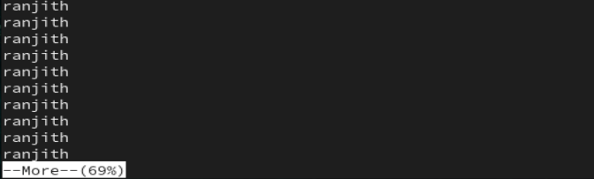
- View the same file using less and compare the behavior.
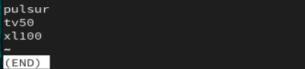
- Identify one advantage of using less over more.
Less allows backword navigation and is faster for large files .this command used for moving the lines bottom to top and top to bottom.its works on n number of times.

- Display a specific number of lines from the beginning of a file.
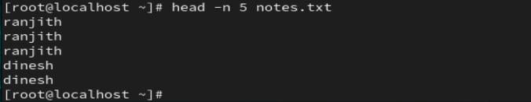

- Display a specific number of lines from the end of a file.
